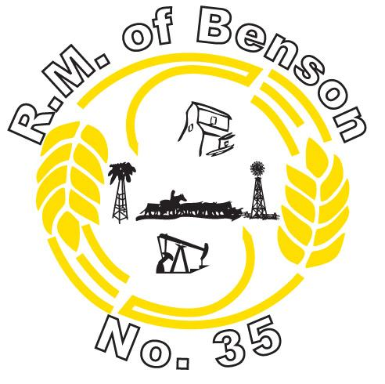

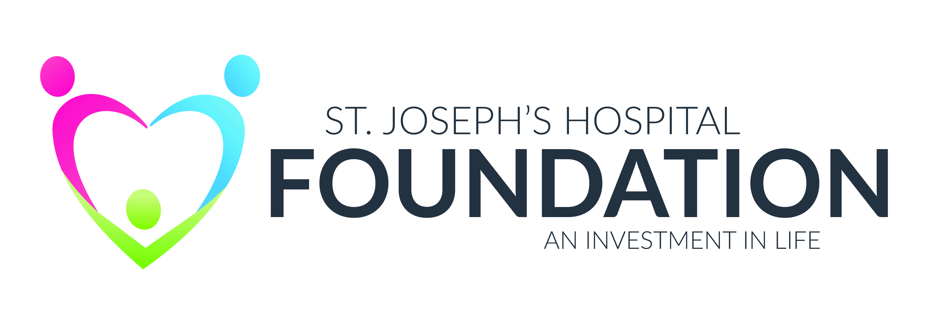

**THE RM OF BENSON / ST JOESPH’S HOSPITAL MRI PLEDGE FORM**

All donations made by May 31st, 2025 will be matched by the RM of Benson to a total of $25,000.00

(Pledge forms can be picked up at the RM office or from Lori- Mention RM BENSON MRI pledge to have your donation matched)

Donor’s Name for Receipt:________________________________

Address:______________________________________________

_____________________________________________________

_____________________________________________________

Phone #:_____________________________________________

E-mail_______________________________________________

PLEDGE AMOUNT:_____________________________________

PAYMENT METHODS (cash, cheque, debit, credit card)